

PERSONAL PORTFOLIO

**Subject: ADVANCE WEB APPLICATION DEVELOPMENT**

**Professor: Carmen Branje**

**Name: KHILAN PATEL**

**Student Number: 300785048**

**Table of Contents**

**Content Page**

**1. Introduction 1**

**2.Brief Description 1**

**3.Nav Bar Section 9**

**4.Colour Section 10**

**5. Typography Section 11**

**6.Wireframe Section 13**

**7.Branding section 16**

**INTRODUCTION:**

**The main aim of the project is to develop a website and make it attractive and user friendly. The website is mainly developed on basis of HTML, CSS, JavaScript and JQuery.**

**BRIEF DESCRIPTION:**

**The Personal Portfolio website consists of different pages. Each page has its own functionality and aspects. The different pages are mention below.**

**1. Home Page.**

**2. About me Page.**

**3. Project Page.**

**4. Services Page.**

**5. GITHUB Page.**

**6. Contact me Page.**

**7. Business contact Page.**

**Home Page:**

**The Home Page which contains a logo (with a Title), a horizontal menu, a slider, Tagline and mission statements. The logo, which is designed using the “Adobe Illustrator”. The horizontal menu which contains links for six other pages have different features like hover, active link on the currently opened page. The slider which mainly revolves around four images. We can move forward and backward for showing different images. There is an option for an Keep connected section which consists of social networking sites such as “Facebook”, ”Twitter” and "Google+". The footer page which contains a copyright message is at the end of every page.**

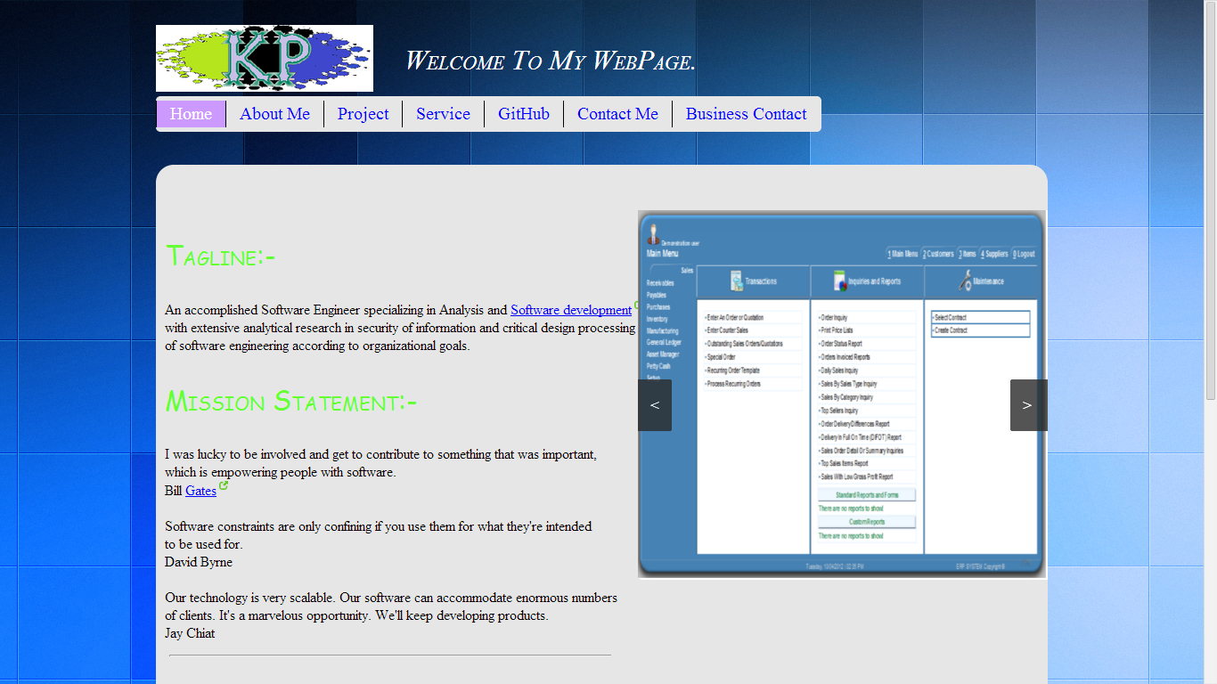

Active Mode

LOGO

MENU

Slider



Social Website Links

**Slider Image:**

First Image of Slider

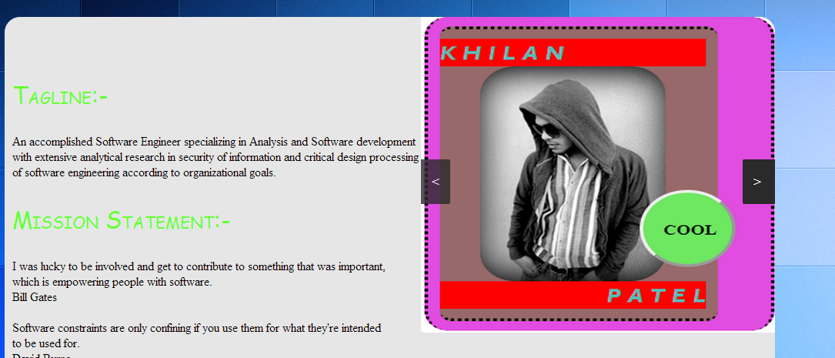

Backward Button

Forward button

**Tagline and keep Connected section:**



Mission statement

Tagline

**Footer Page with copyright message:**



Footer section with copyright Statement

**About me Page:**

**The “About me” Page which explains more about me and my resume that describes my education and experience .The page which also contains a picture inside the resume.**

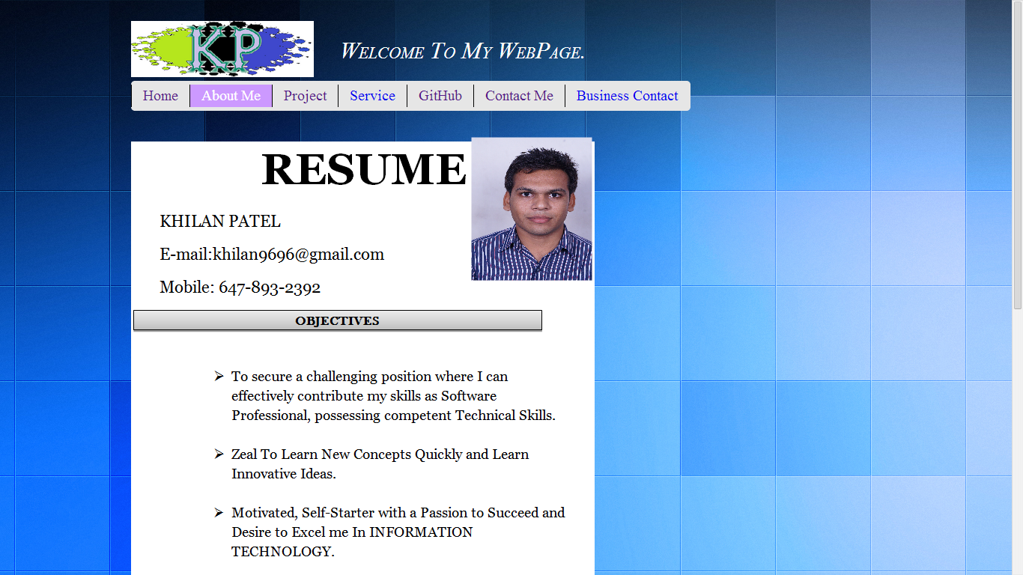

Resume

Image

**Project Page:**

**Four different projects are mention in the project page. When we click on that project we can see the full description of that project in the different page.**

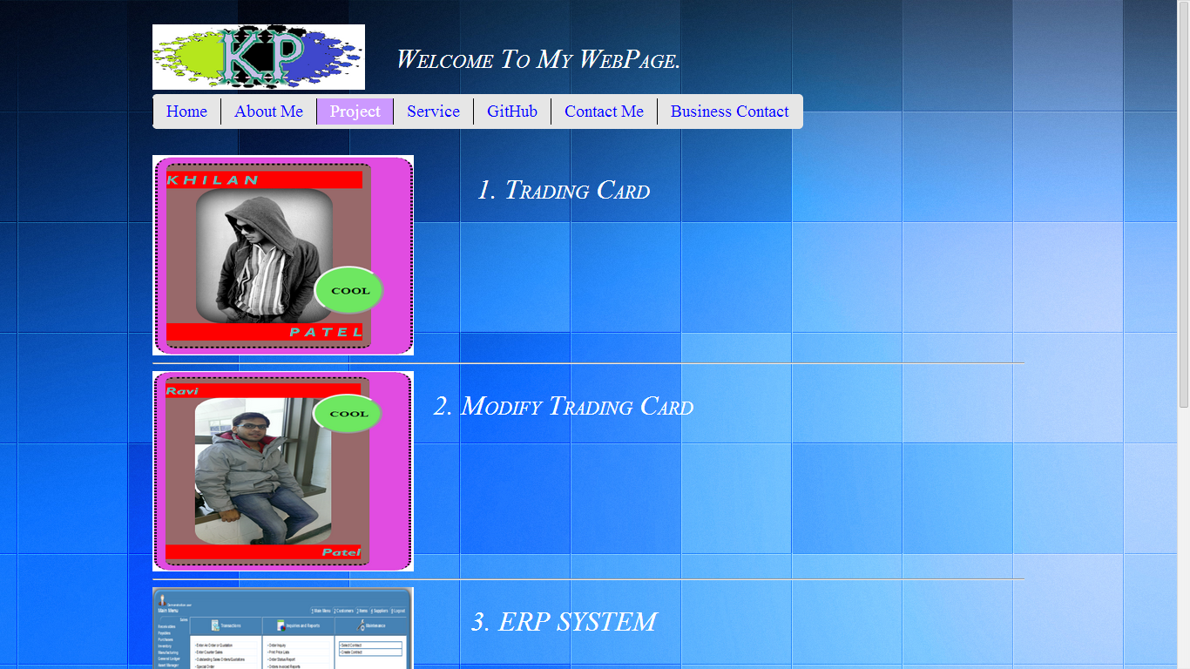

Project-2

Project-1

**Service Page:**

**Different types of services provided by us. Mainly four services are mention in this service page. There are some different images according to that services.**

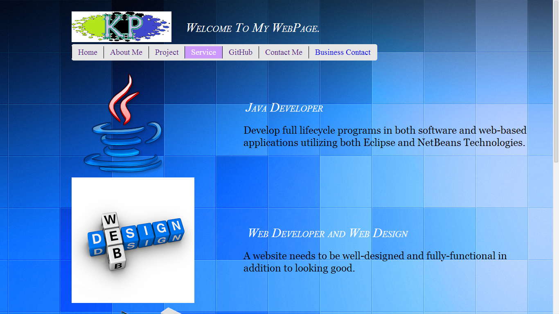

Service-2

Service-1

**Contact Me Page:**

**Cell number, E-mail address, residential Address are mention in the contact me page. Also three social website links are mention below of the page. Get direction feature is also there so anyone can easily find the location.**

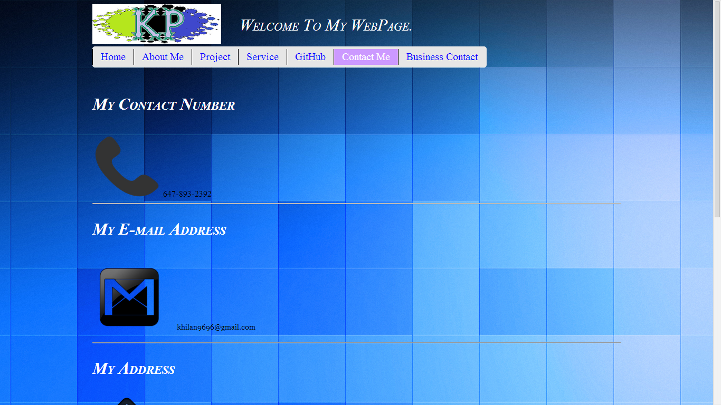

E-mail Address

Contact Number

**Nav Bar Section:**

Menu



Active Page

Business Contact

**The menu bar contain seven blocks. Each block has each different page. When we hover on that block then colour is changed and when we click on that block the background colour will be changed.**

**COLOUR For All Pages:**

|  |  |
| --- | --- |
| **DIVISION/TAG/PARAGRAPH** | **COLOUR/VALUES** |
| **P Tag** | **#6F3** |
| **H1 tag** | **White** |
| **Contain-area** | **#E6E6E6** |
| **Footer** | **#0099FF** |
| **Menu** | **#E6E6E6** |
| **Hover** | **#0F0** |

**Typography Section:**

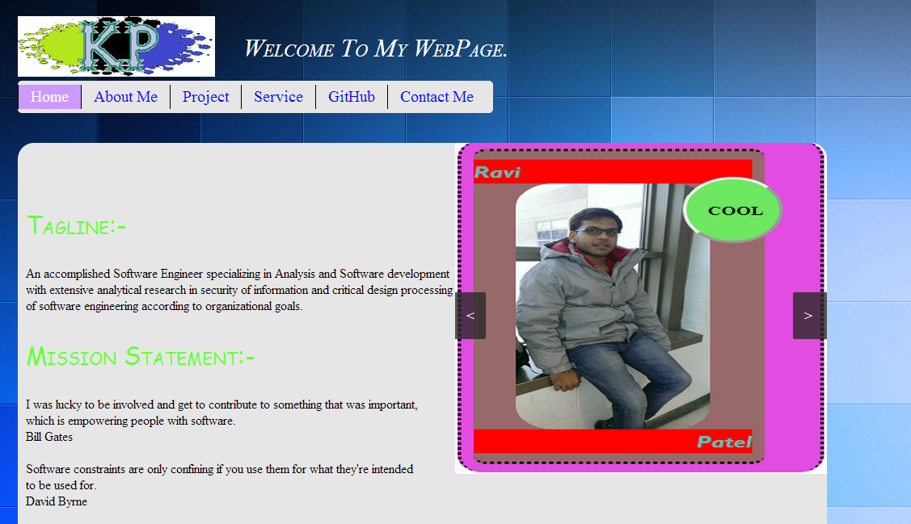

6

5

4

3

2

1

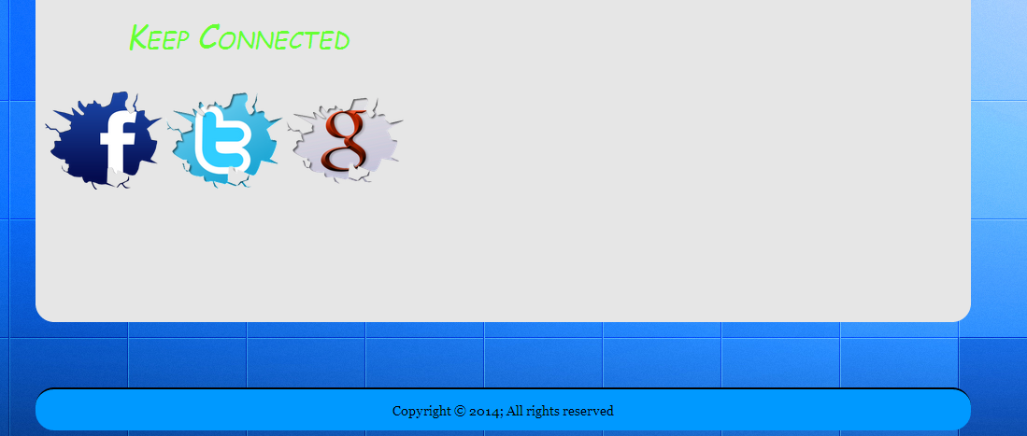

7

|  |  |  |
| --- | --- | --- |
| **Arrow No** | **Tag Name** | **Description** |
| **1** | **H1** | **Colour: White**  **Size:36%**  **Font-Family: webkit-pictograph** |
| **2** | **Logo(image)** | **width:244px**  **height:75px** |
| **3** | **Menu** | **width:588px**  **height:40px**  **Colour: #E6E6E6** |
| **4** | **Contain-area background** | **Size: 400px**  **Colour: #E6E6E6** |
| **5** | **H1 tag in Contain area** | **Size: 30px**  **Colour: #6F3** |
| **6** | **P** | **Size: 30px**  **Colour: black** |
| **7** | **footer** | **Size: 44px**  **Colour: #0099FF** |

**WireFrame Section:**

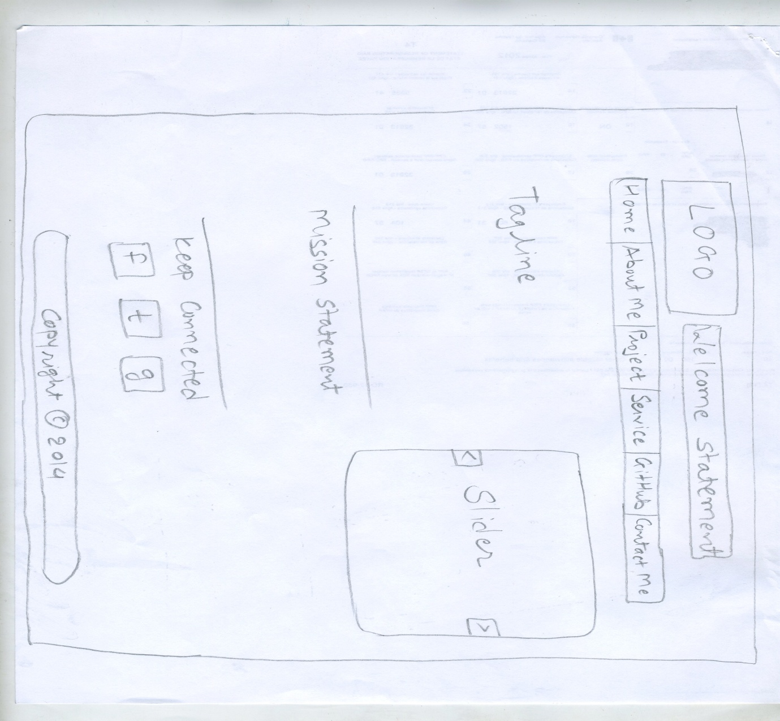

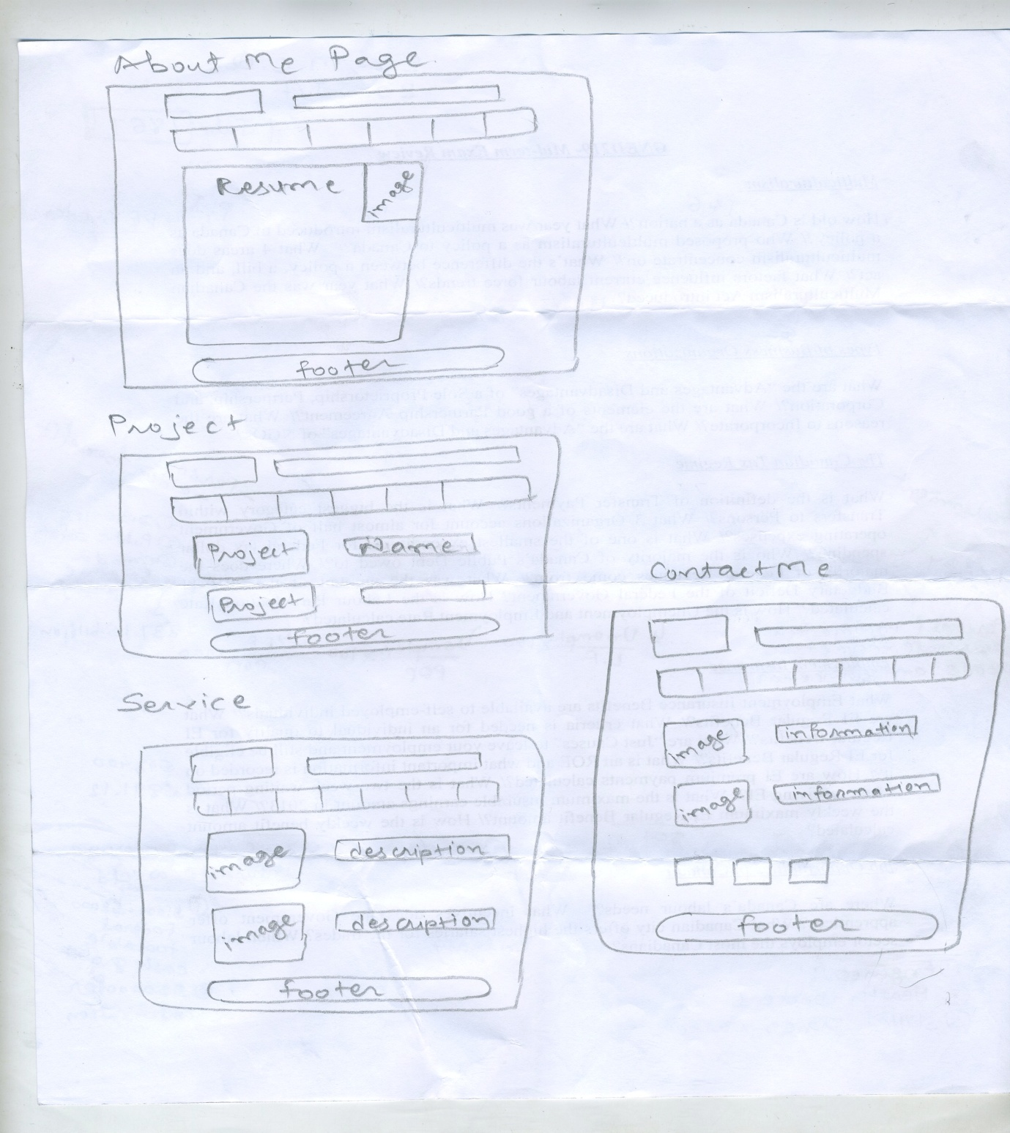

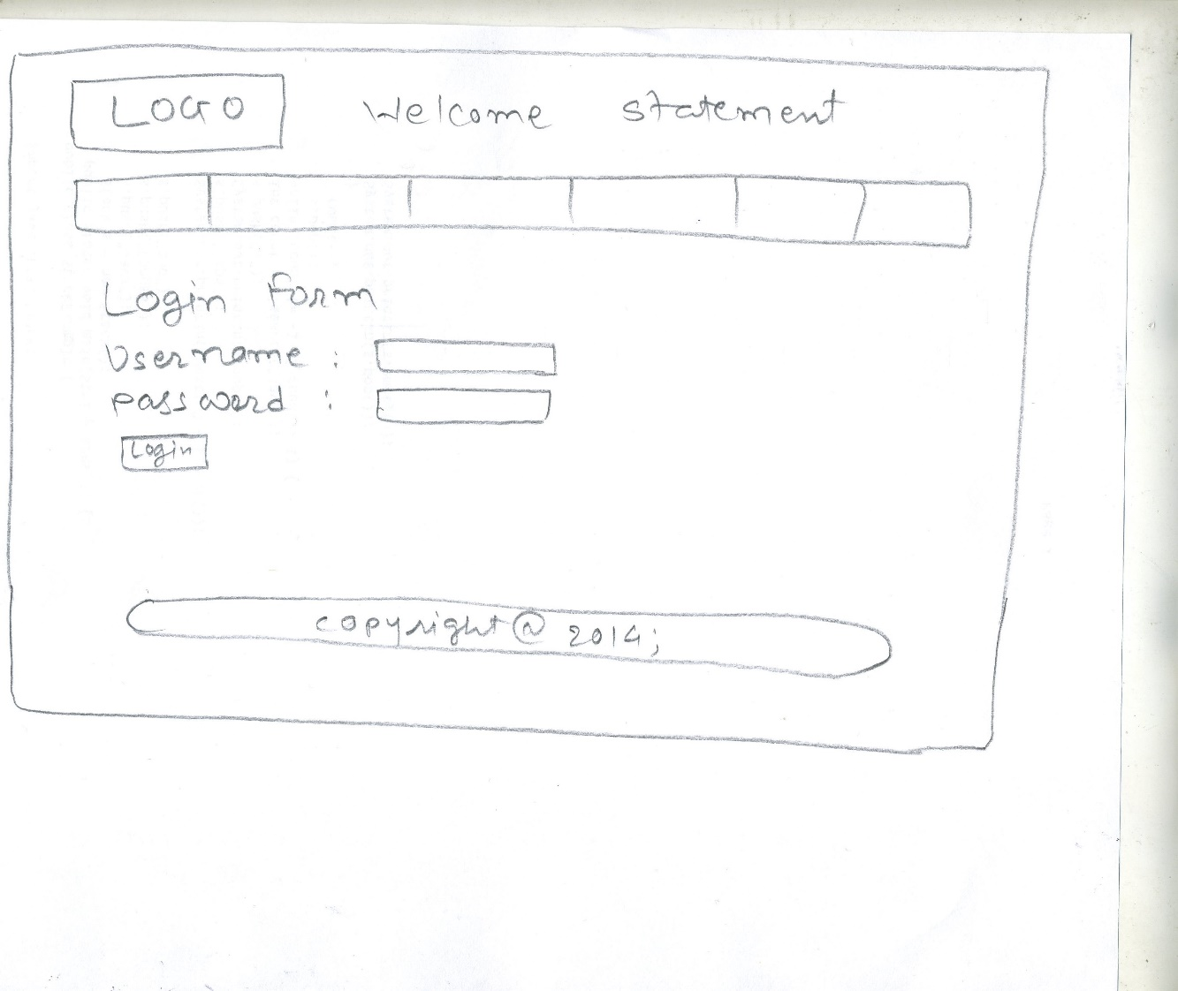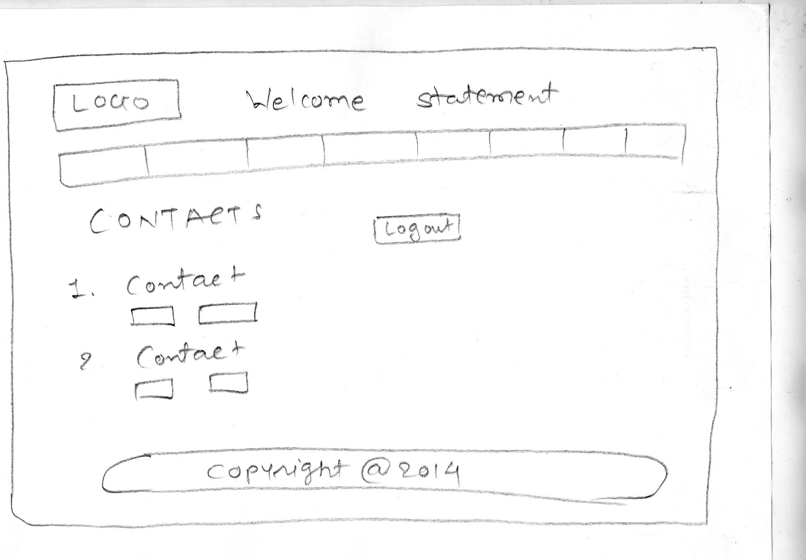

**Branding Section:**

**Home Page:**

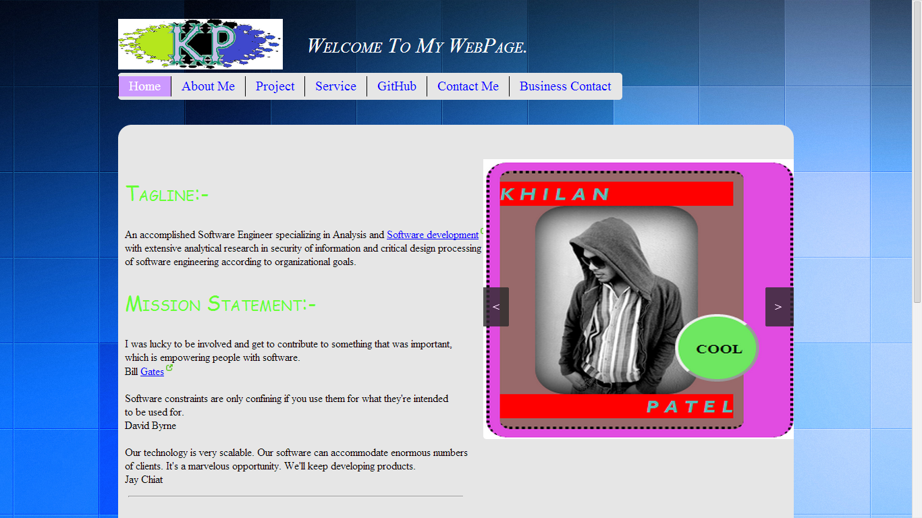

**About Me Page:**

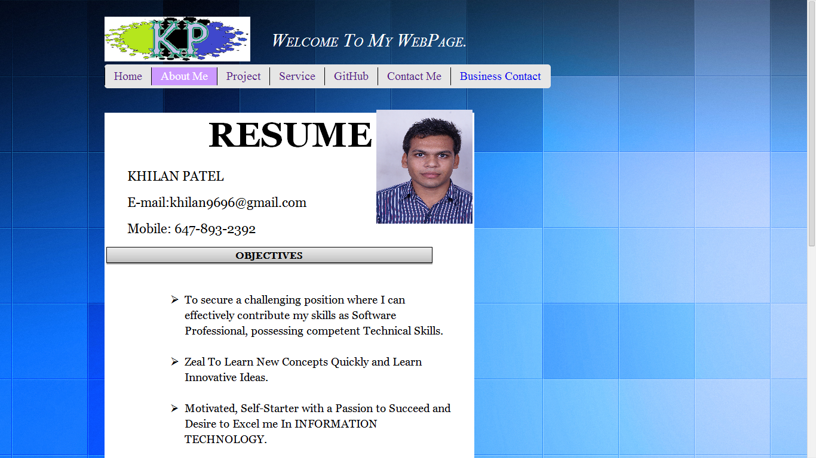

**Project Page:**



**Service Page:**



**Contact Me Page:**



**Business contact Page:**

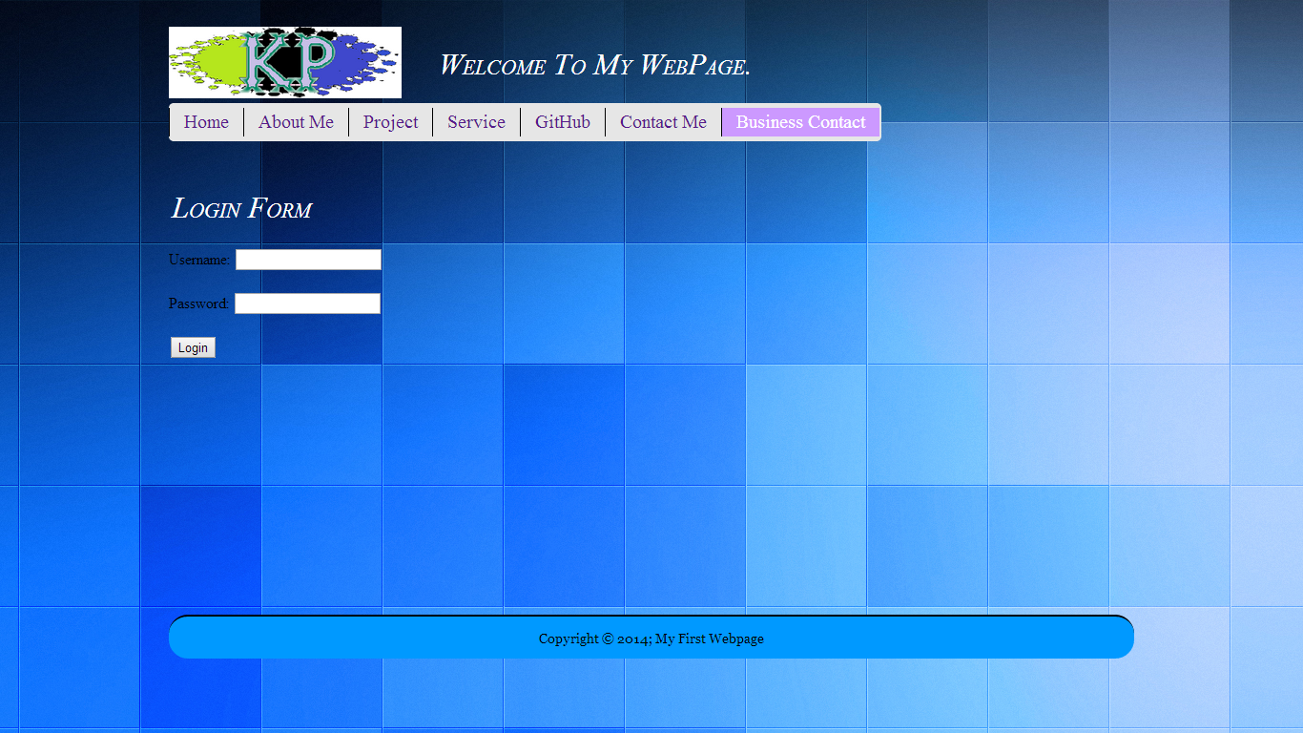

**Business Screen Page:**

